Write With AI
Write A "How To" Medium Article
That Gets Shared, Bookmarked, And Read 1,000 Times





Nicolas Cole
and
Dickie Bush
Jun 02, 2024
∙ Paid

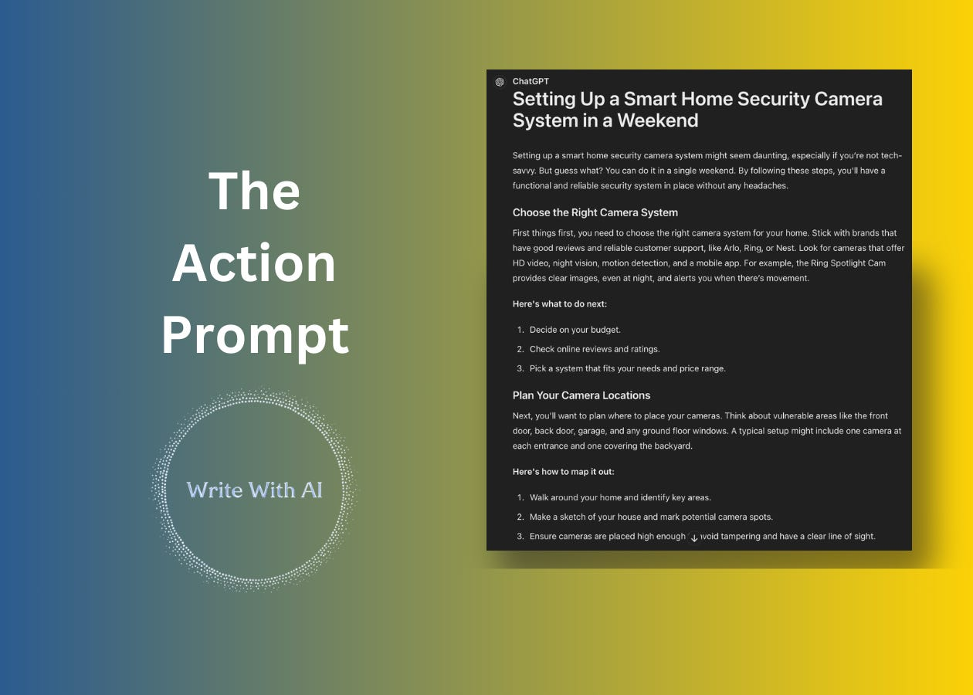

Hey there, Digital Writers!
If you want to write a Medium article that gets shared, bookmarked, and read 1,000 times, the "secret to success" is that you are NOT just writing an educational article.
Readers aren’t looking for more information.
Instead, what you're really doing when you write a Medium article is giving readers 3 things:
- Action Steps
- Templates
- Support
Here's why:
Most articles on Medium get buried under the avalanche of content uploaded every day. Think about that. You publish an article, and it’s only read by a handful of people. The reason that’s such a problem is because the #1 factor determining the success of your growth (and how much you get paid) on social platforms like Medium is a) how many people read your writing all the way through, which determines b) how many people go on to share it. (Chances are, you’ve shared a great article with someone before!)
The takeaway here is that your goal isn’t just to publish more informative articles. Your goal is for people to read your articles, love them, and share them with others.
And how do you get people to not just read, but share—and then recommend your article?
- Action Steps
- Templates
- Support

“Teaching” makes the reader’s eyes glaze over.
The more you give something to DO, the more engaged your reader will be, the faster they learn, the more successful they become, and the more they’ll tell other people about your work.
So, for any article you write, your goal is to be clear on what the ACTION is that people can take:
- Are you teaching how to do your taxes? Don’t just explain it. Give the student something to DO.
- Are you teaching how to be more productive as a project manager? Don’t just explain it. Give the student something to DO.
- Are you teaching how to build a SaaS product? Don’t just explain it. Give the student something to DO.
Action, action, action.

Action is the secret.



To do this you want to make the DOING as easy as possible.
You do that by giving people templates:
- Are you teaching how to write viral headlines? Give beginners a “viral headline” template they can use and practice with immediately.
- Are you teaching how get 6-pack abs? Give beginners a workout template they can use and practice with immediately.
- Are you teaching people how to write with AI? Give beginners a "prompt" template they can use and write with immediately.
Templates reduce the fear & friction of getting started and remaining consistent—and getting started & remaining consistent are the 2 biggest things your writing needs to solve for.
The big thing to keep in mind here is nobody is paying with their attention for you to talk and sound smart.
Readers are looking to you for the guidance, the action steps, the templates, to make a change in their lives. And their success is a function of your ability to take them by the hand, give them things to DO, and make sure those ACTIONS are the right steps to get them FROM where they are TO where they want to be.
Now, let’s look at how you can leverage AI to help you make your Medium articles more actionable using, you guessed it…a prompt template!

The Ultimate AI Writing Prompt For Actionable Content
We are going to do this in 3 simple steps.

Step 1: Choose Your Topic And Desired Outcome
First, select a topic that aligns with your niche and identify the specific outcome your readers hope to achieve.
For example:
- If you're writing about weightlifting, your desired outcome might be building muscle mass for software engineers who don’t have access to a gym.
- If you're writing about budgeting, your desired outcome might be saving $10,000 in a year for recent college graduates who don’t want to give up weekly coffee shop visits.
- If you're writing about task management, your desired outcome might be completing daily to-do lists for freelance graphic designers even if you don’t use a project management app.
- If you're writing about drafting articles with AI, your desired outcome might be creating 1,000-word Medium posts for freelance writers who don’t want to spend hours editing.

Step 2: Copy/ Paste The Action Prompt Into An AI LLM
Here’s the prompt:

TASK: Write a 1,000 word Medium article about {TOPIC}. Each section should be 100-150 words.

ROLE: Act as an insanely talented ghostwriter/copywriter.

TONE: Helpful, conversational, action-oriented, and blunt and direct.

STYLE: Clear, concise, organized, with a mix of short and long sentences. Good use of line breaks and a style that makes you want to continue reading from one sentence to the next.

CONSTRAINTS:

The article must be highly actionable (and easy for the reader to put to use immediately).

- Give them specific steps
- Reinforce the steps with examples
- Give them a template (when appropriate)

Instead of using labels like 'Example:' or 'Action Steps:', weave the instructions naturally into the text, using conversational phrases like 'For example,' or 'Here’s what to do next.' or 'Here are 3 steps to get started:' or 'To get started, follow these 3 simple steps to {outcome}:' etc.

Be specific. Use concrete, tangible language.

1. **Replace Abstract Words**: Instead of abstract terms like "love" or "anger," use concrete images or actions that represent these emotions. For example, rather than saying "she felt love," you could say "she hugged him tightly, her eyes shining with warmth."

2. **Use Specific Nouns**: Rather than using general terms, specify the type or kind. For instance, replace "tree" with "oak tree," "shoes" with "Oxford shoes," and "painting" with "watercolor painting." This creates a more vivid image in the reader's mind.

3. **Detail Finer Distinctions**: When categorizing characters or objects, think about the more specific levels. For example, instead of just "chef," specify "sushi chef," "food truck owner," or "gastropub owner." This adds depth and precision to your descriptions.

4. **Minimize Adjectives and Use Strong Verbs**: While adjectives add detail, overusing them can weaken your prose. Opt for strong, specific nouns and verbs instead. For example, "He walked slowly" can become "He trudged."

5. **Avoid Jargon**: Use language that is clear and easily understood by a broad audience. Avoid industry-specific terms unless your audience is familiar with them.

6. **Replace Non-Specific Words**: Words like "some," "thing," and "sometimes" are vague. Replace them with precise details. For example, instead of "We spent some time at the party," write "We spent 30 minutes at the party." Instead of "I picked up some things at the store," write "I picked up olives and garlic at the store."

7. **Provide Specific Examples**: Rather than general statements, offer detailed examples. For instance, instead of saying "I exercise regularly," specify "I take a brisk walk for 30 minutes three times a week," or "I do a 45-minute bodyweight workout every day at home."

Step 3: Run The Action Prompt
Plug your {TOPIC} into the prompt and hit enter.
For example, I used the topic “How to setup up a smart security camera system in a weekend (even if you’re not technical).”

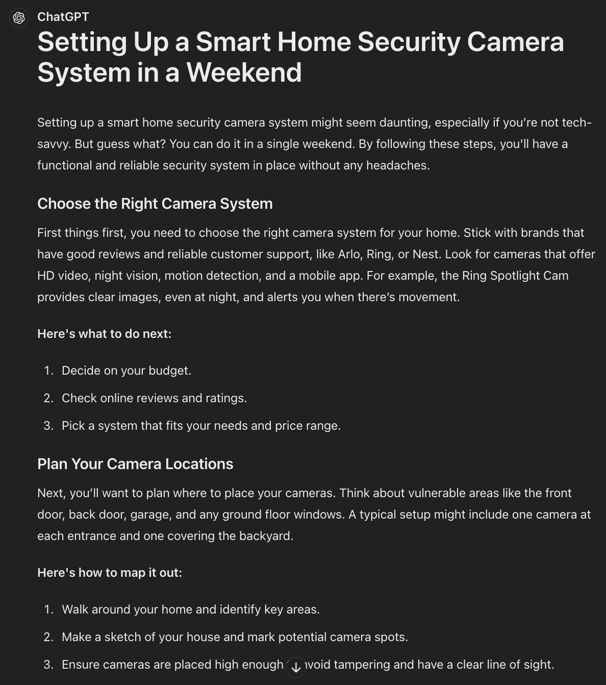

Read through the AI output.
Make any necessary adjustments, and add your personal touch. Look for any spots that could use further clarification or areas where you could be even more specific for the reader.
The Action Prompt does a good job of incorporating steps, examples, and templates, but depending on your topic, it may struggle to reach the level of specificity that makes your writing come alive.
In the example output above, you could enhance the "Decide on your budget" step by providing guidelines. For instance, what feature tradeoffs might the reader encounter when choosing between a more economical security system and a pricier one? Additionally, for the "Plan Your Camera Locations" step, consider including an image demonstrating a good and bad camera setup. A visual aid could help you illustrate how blind spots are created and where the "bad guys" could get in.
Keep asking yourself how you can be more specific and helpful.
Edit until you're satisfied.
Then, copy and paste the article into Medium and hit publish.
That’s it.
Remember, your success as a Medium writer hinges on your ability to guide readers, provide actionable steps, and empower them to make meaningful changes in their lives.

